3)Cold Migration of VM from one host to another

Aim:
To perform cold migration of a virtual machine (VM) from one host to
another using the export/import appliance method (OVA format) in order to transfer VM configurations and disk data seamlessly while the VM is powered off.

STEPS:
Prerequisite
- VM must be shut down (powered off).
- Both systems (source and destination) must have VirtualBox
- Ensure enough storage on destination host.
- Created a java file to check whether the same file exist in vm after imported(cold migrated ) in another system
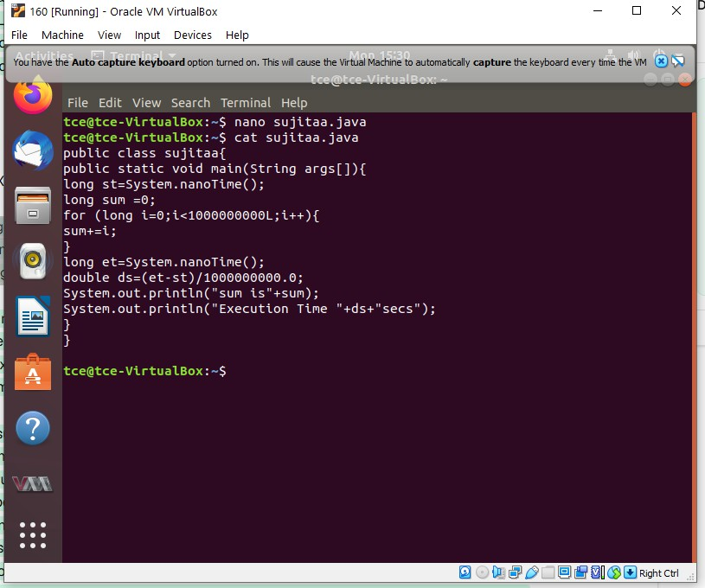

- Shut down the VM completely. Open VirtualBox and select the VM → Click File > Export Appliance (or File > Export OVF).
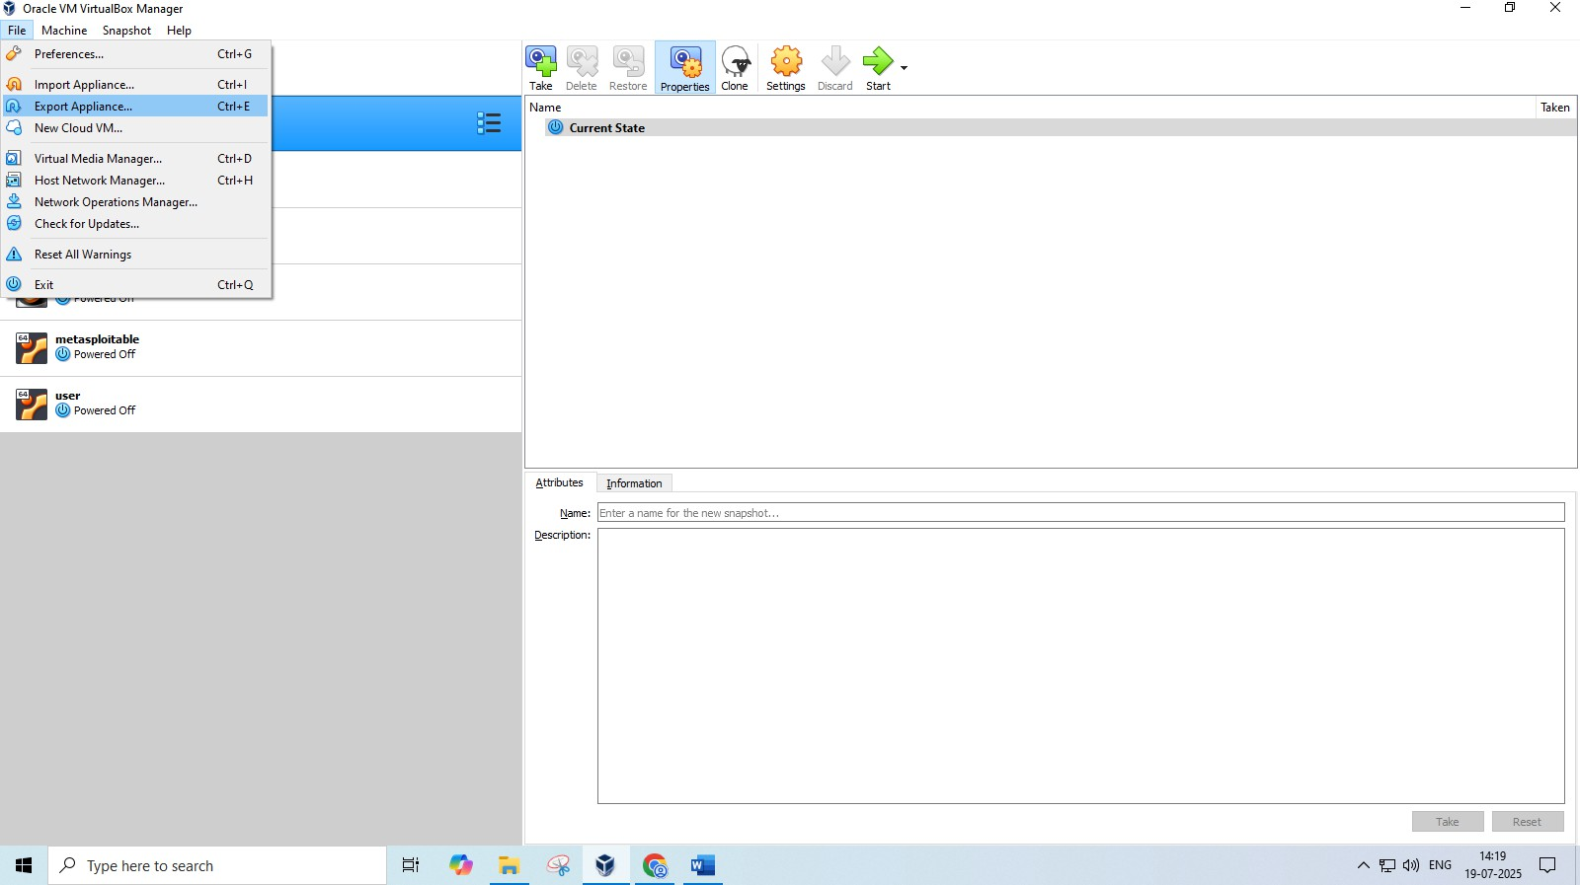

- Select the vm which you want to export
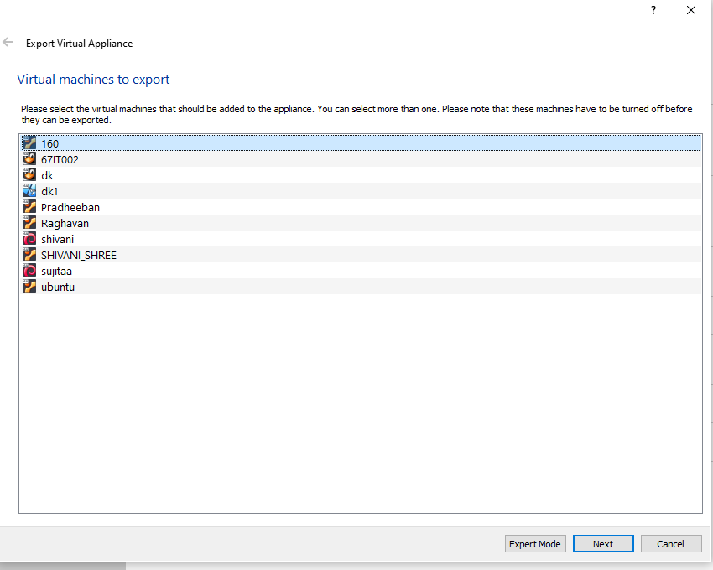

- Select the format which you want to export ova or ovf file format and select the path where you want to export in the file system
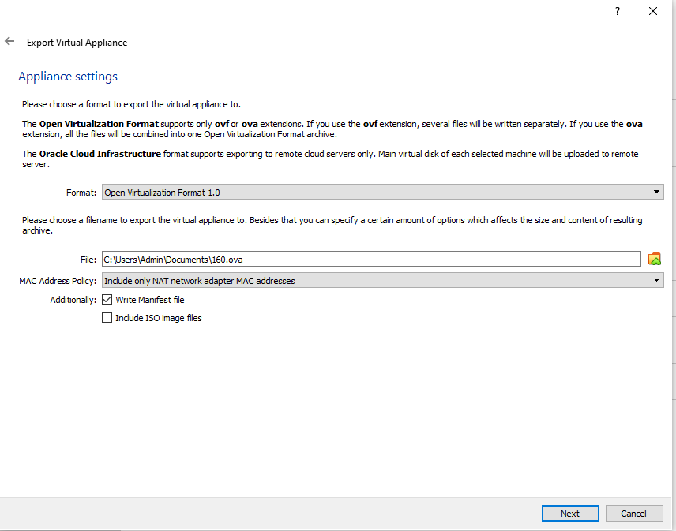
- Click export to (export appliance to the file system where you selected the location)
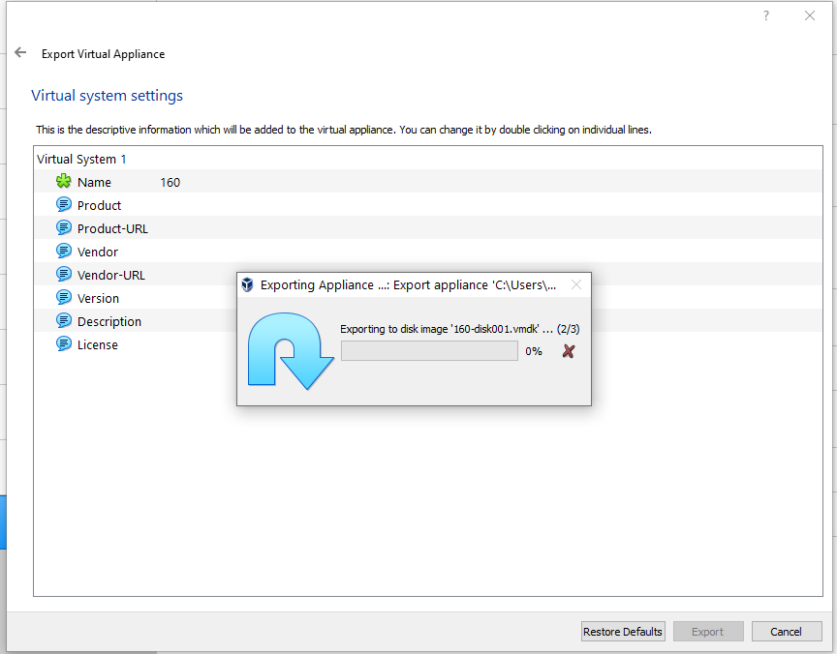

- Check the folder whether the ova image has been present in the folder
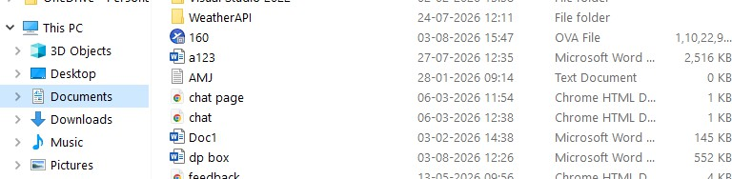
- Copy the image to the external device via internet
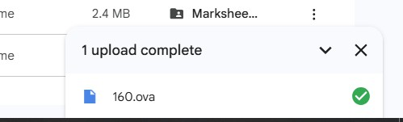
- Copy the image from your external device to the destination machine via internet

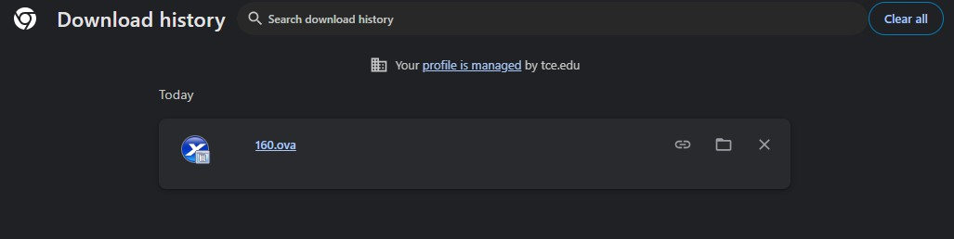
- On the Destination Host: Import the OVA Open VirtualBox Go to File > Import Appliance (or File > Open). Browse and select the .ova file you transferred.

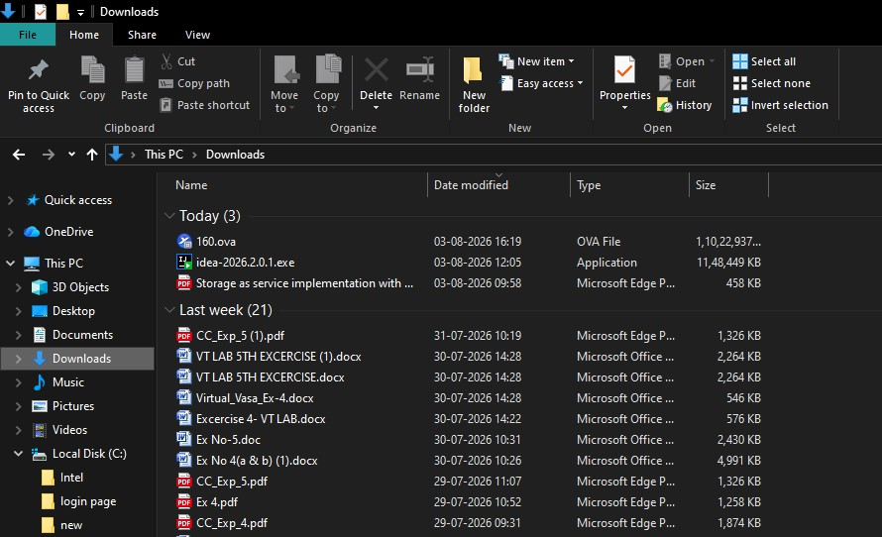

- Import the image by import appliance in the file ->import appliance
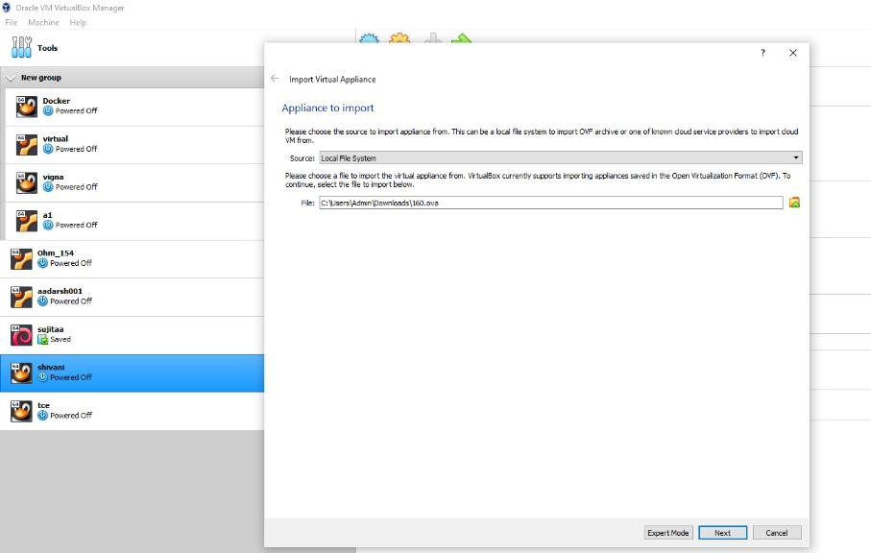
- Now the image has been importing
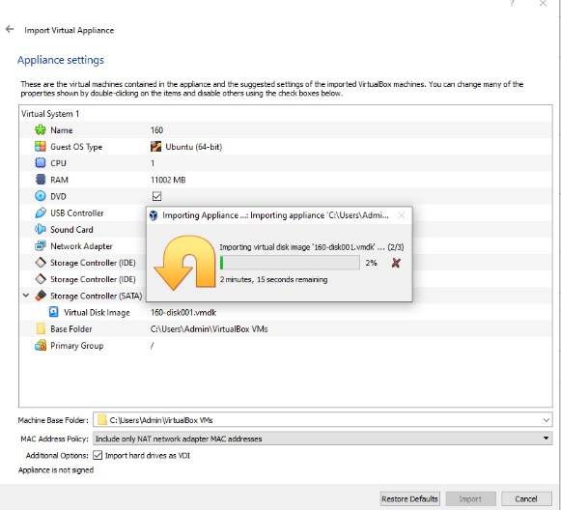

- Check whether the vm is shown in the oracle virtual box and open it
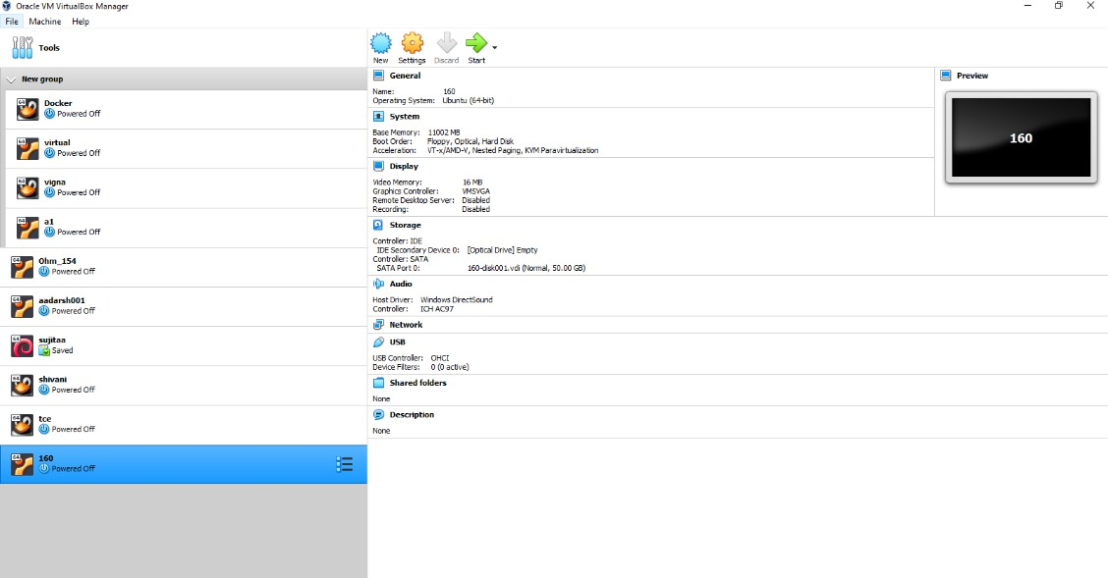
- Open the java file which you saved first using the linux commands cat kesho.java And its verified that the file are located and cold migration has done
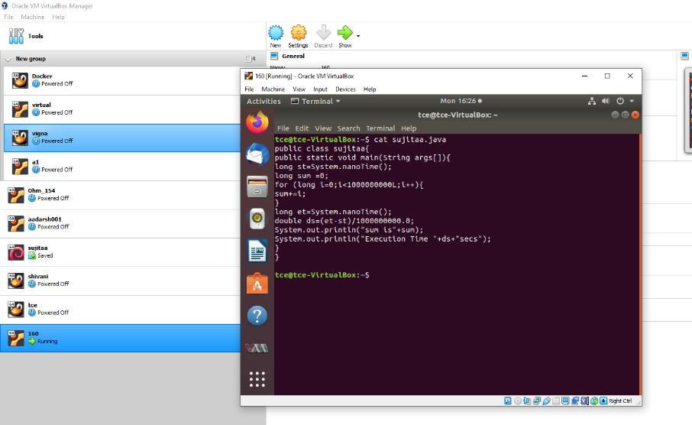

RESULT:
The virtual machine was successfully migrated to the destination host in a powered-off state(cold migration) using the OVA export/import method. All configurations and data were retained, and the VM booted up and functioned correctly on the new host.

